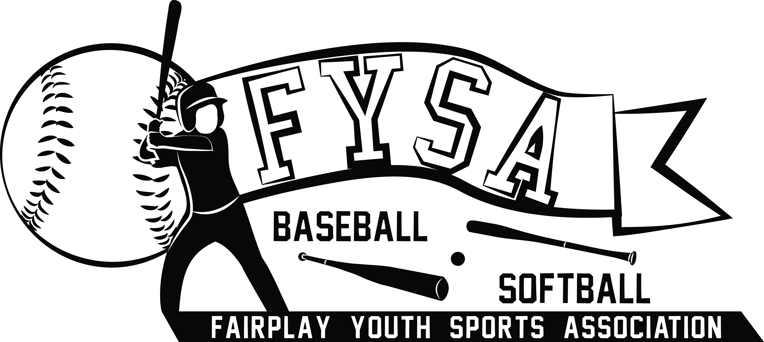

Fairplay Youth Sports Association, Inc.

PO Box 1351
Douglasville, GA 30133-1351

Spring Baseball and Softball Sponsorships

FYSA is a not for profit organization that provides baseball and softball programs in the Fairplay community of Douglas County. We strive to keep cost to the families minimal which makes community sponsorships key to the success of each season. FYSA has several levels of sponsorships that businesses in the community may contribute to. FYSA is a not-for-profit organization which makes your donation tax-deductible.
Please see below for the optional levels of sponsorships. All monies will go to offset the cost of uniforms, needed equipment, tournament fees, instruction, training and awards.

Platinum Sponsor - $300.00 – Large 3x5 banner + Website link

Gold Sponsor - $250.00 – Medium 2x4 banner

Silver Sponsor - $200.00 – Small 2x2 banner

Bronze Sponsor - $100.00 – Logo on 3x5 multi-sponsor banner

Contributing Sponsor - $________________

Banner to read as follows:

Please provide specific graphics/logo on a CD for banner printing. The image needs to be a Hi- Resolution graphic. Please send artwork to robert@fairplayyouthsports.org

For team sponsorships please list team name and coach:

Please make all checks payable to: FYSA

Thank you for your support!

